Carry Forward Clean-up
The amount available to be carried forward is determined by the following and how each chart string ended the fiscal year:
Prior Year Carry Forward Actuals/recognized revenue (Prior year 499XXX)
+ Current year revenue actuals/recognized revenue (4XXXXX)
- Current year expenditure actuals (50000-999999)

Example How-to calculate:
Report reflecting the FY20 year-end figures:
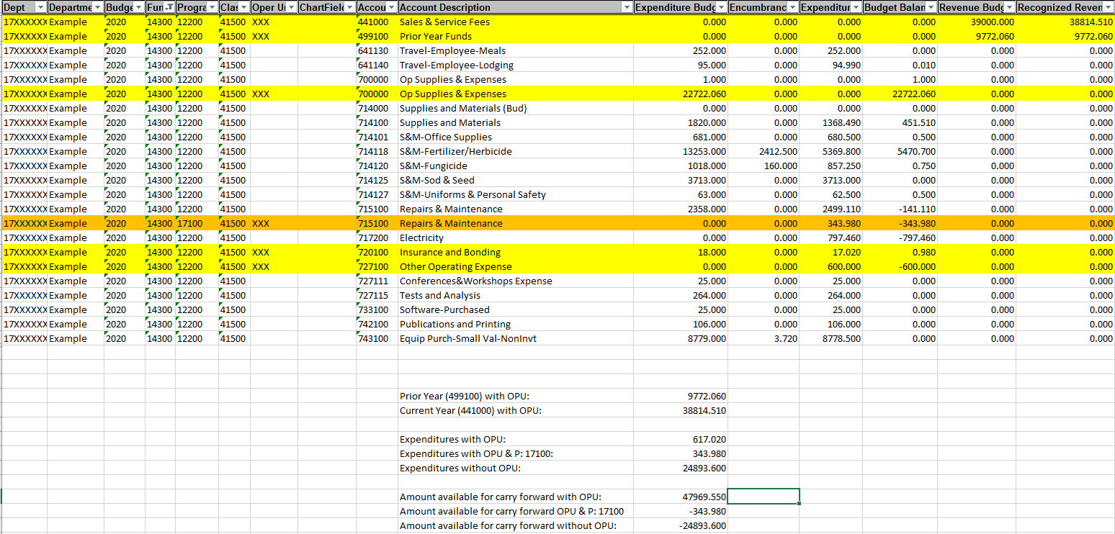
Report reflecting FY21 carry forward figures:

Negative recognized revenue and budget can be corrected; however, it can NEVER be moved out of account code 499XXX and can NEVER be moved from the fund it was originally recorded.
To correct the negative chart strings, there are a total of three journals that need to be submitted:
- GL Journal to correct the recognized revenue
- Budget journal to correct the revenue budget
- Budget journal to correct the expense budget
*Carry forward corrections can include the cents and do not have to follow the normal whole dollar rule**

Using the above example with the FY21 carry forward figures:
- GL journal lines will be as follows (corrects recognized revenue):
  - A: 499100, F: 14300, P: 12200, D: 17XXXXXX, C: 41500 Amount -$24893.60
  - A: 499100, F: 14300, P: 17100. D: 17XXXXXX, C: 41500, OPU: XXX Amount -$343.98
  - A: 499100, F: 14300, P: 12200, DL 17XXXXXX. C: 41500, OPU: XXX Amount: $25237.58
- Revenue budget journal lines will be as follows (corrects revenue budget):
  - A: 499100, F: 14300, P: 12200, D: 17XXXXXX, C: 41500 Amount $24893.60
  - A: 499100, F: 14300, P: 17100. D: 17XXXXXX, C: 41500, OPU: XXX Amount $343.98
  - A: 499100, F: 14300, P: 12200, DL 17XXXXXX. C: 41500, OPU: XXX Amount: -$25237.58
- Expense budget journal lines will be as follows (corrects expense budget):
  - A: 700000, F: 14300, P: 12200, D: 17XXXXXX, C: 41500 Amount $24893.60
  - A: 700000, F: 14300, P: 17100. D: 17XXXXXX, C: 41500, OPU: XXX Amount $343.98
  - A: 700000, F: 14300, P: 12200, DL 17XXXXXX. C: 41500, OPU: XXX Amount: -$25237.58

The end result/goal should always be to have positive carryforward. However, in a case where the parent overall is positive but there is a child chart string that is negative and cannot be corrected within itself then that clean-up can be determined at the end of the current fiscal year.
- What should be determined at the end of the current fiscal year if you were not able to complete the carry forward clean-up at the beginning of the fiscal year:
  - Did you bring in enough recognized revenue to cover the prior year’s negative carry forward and the current year’s expenses?
    - If Yes, then no clean-up is necessary. This is because negative carry forward revenue can only be corrected within the account code 499XXX, and not with the current year revenue account codes (4XXXXX).
    - If no, then you will need to review where the funds will come from to cover the negative so that the following fiscal year is either 0 or positive carry forward.

